**Design Guide**

**SWOLE Team 6**

**GAM 200**



**Design Overview**

High Concept:

Fast-paced 2D arcade-style hack and slash that relies on platforming and slasher mechanics for engagement and progression.

Target Audience:

Our target audience is that of players 10 years of age or older that are interested in a fantasy hack and slash side-scroller. Players that enjoy fighting hordes of enemies with swords and magic should enjoy this game or at least want to give it a try. Our art style is very cartoony

Rating:

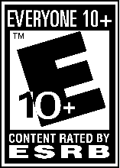

Selling Points:

* Action packed
* Fast paced
* Become a Master Ninja!
* Mystical Powers

Summary:

NinjaCade is a fast-paced arcade-style sword fighting game where the player uses various combos tied to mouse movement to defeat enemies. Throughout the story the player will collect multiple scrolls of power that will enable them to use powerful abilities that are iconic to the story’s theme and lore.

Game Flow:

The player will move through levels (from left to right) as they defeat enemies, manipulate objectives, and gather scrolls of power. This will include intensity peaks of engagement with hoards of enemies followed by brief segments of rest. The game also incorporates high-intensity peaks at boss fights that require higher-level engagement and make for more intense gameplay.

Game Duration:

A single level will consist of around 3-5 minutes of gameplay which will make up episodes that consist of 2-3 levels each.

Experience:

The intended experience for the game is relatively fast paced “fruit ninja” like combat where players drag the mouse in a precise fashion to execute combos and special abilities that will allow them to defeat their foes and increase their combo counter that enables the use of scrolls. Other elements of engagement revolve around platforming/objective retrieval so that players are not constantly fighting enemies but have some gaps of fresh air in between combat sequences.

End of Gameplay:

Player wins by completing a primary objective or simply by moving to the end of the level.

- Collecting specific items to complete a level ([not yet implemented]

- Timer based objectives [not yet implemented]

- Survival scenarios against waves of enemies [not yet implemented]

- Player stats are shown at the end of each level (enemies killed, highest combo, damage taken, player choices, etc.) [not yet implemented]

**Competitive Research**

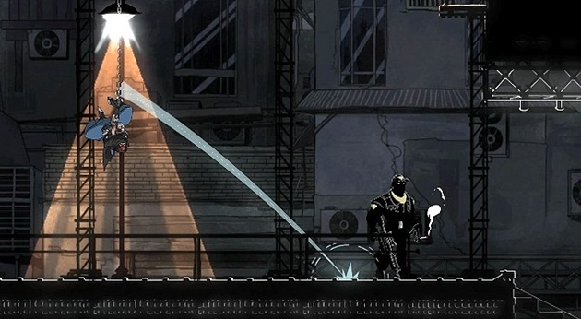Mark of the Ninja:

* Side-scrolling swordsman game that could either be stealthy or combat heavy.
* Good reference for different attacks and animations for our main character.

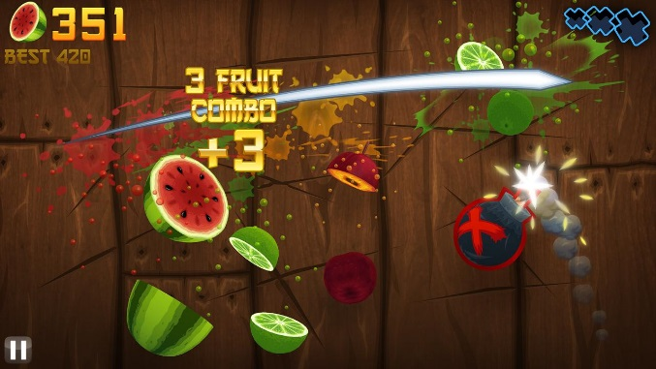

Fruit Ninja:

* All character attacks are directly controlled by the player clicking and dragging their mouse.
* Visceral, fast-paced gameplay.

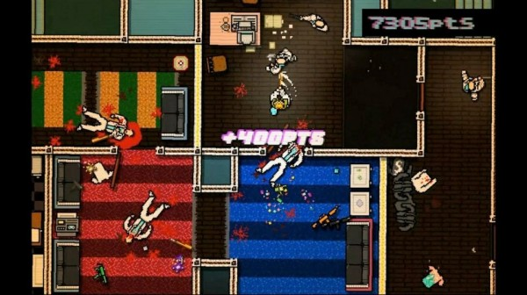

Hotline Miami:

* Swarm the player with enemies that can be quickly mowed down, but can overwhelm them if they aren’t fast enough.

**Mechanics Overview**

Game Mechanics:

- Movement: Basic platforming movement of left/right movement in combination with jumping.

- Basic Attack: Standard attack cycle that strikes enemies in front of the player. Slashing mechanic that involves dragging the mouse through enemies. Attack accumulate energy for using scrolls of power.

- Slash Attack: When the player clicks and drags in a direction, they perform a Slash attack that rapidly moves them in the direction of the mouse movement and damages all enemies in their path.

- Scroll Attack: [not yet implemented] When the player has enough energy, they can expend it to active one of their magic scroll power. These scrolls each damage enemies in different ways and are based off of sacred animals (tiger, dragon, snake, etc).

- Combos: counter used for damage modifier and increase in energy accumulation.

**Character Overview**

* Player: Zordra, a ninja who uses a sword as a primary means of defeating enemies.
* Mob Enemy: chases the player when in range, is low health and defenses
* Ran-Tan & Ulna: a slow moving enemy with medium amount of health. This enemy uses heavy swipe attacks at melee range but also uses fire at short to medium range.
* Bosses: End of episode encounters that offer a challenge to the player and reward them with a scroll of power for succeeding.

**Interface Overview**

Controls:

* “A” and “D” buttons move the player left and right.
* Spacebar lets the player jump (and double jump if they’ve unlocked that power).
* L-Click makes the player attack in the direction facing the mouse cursor.
* L-Click and Drag makes the player do a slash attack in the direction of the mouse movement, moving through enemies quickly and attacking everything in their way.

HUD:

* Player Health: Top-left of the screen. This will be a red bar in the shape of a sword shown over a larger, dark sword outline to show how much health the player has in relation to their maximum.
* Player Energy: Top-left of the screen. This will be a blue bar in the shape of the sword edge just under the blade shape of the health bar.
* Combo Counter: Top-left of the screen. Number counter inside of an ink circle that shows the player how high their current attack combo is, and how high their maximum combo is for this level.
* Level Timer: Top-center of the screen. It counts down until the player loses the current level. This HUD element will only be shown on levels that have a timed element to them.
* Power Scrolls: Top-right of the screen. The player can have up to 3 of their scrolls of power loaded out when they enter each level. These scrolls are lined up vertically on top of each other with the center scroll significantly larger than the top and bottom. This larger scroll is the one that is currently selected, and can be changed by scrolling up or down on the mouse wheel.

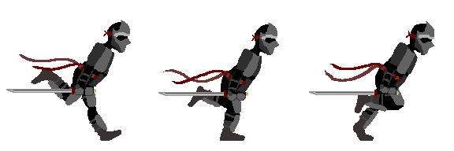**Resources Overview**

**Art:**

* 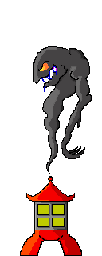The main character is a Ninja who dashes around with a sword. The sprites we have so far are the run animation, idle, slash, and one basic attack. The animations we’re aiming to have for final submission are a full sequence of basic attack cycles, jumping, death, hit reaction, and at least one “use ability” animation.
* Currently, the only enemy we have is a possessed lantern called Ulna. They are going to be our fodder enemies that just run toward the enemy and whittle down their health. Later on we will have floating samurai armor, evil ravens, and a multi-armed goddess boss.
* 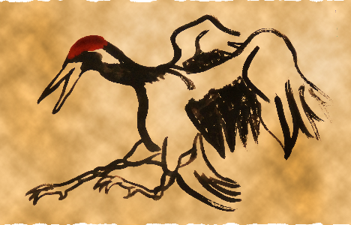For our scrolls of power, we have one of the five animal paintings finished (crane), and we will have the tiger, snake, boar, and dragon for final submission. The crane scroll we have right now is also animated so that when the player completes the timed scroll event, the scroll fills in as if it was being painted.
* For our levels, we have a tile map of basic building parts so that we can create different buildings for our level 1. In the future, we will have tile maps for a dark forest and a temple, as well as the interior for our tutorial dojo.

**Audio:**

* [Current Music Isn’t Final] The music for our game is intended to be very upbeat to match the fast pace of our gameplay. As for the style, we want it to be very similar to the music in One Finger Death Punch: a hybrid of techno and traditional Japanese instruments.

**Environment Overview**

Basic 2-D platforming environment mechanics with platforms, terrain hazards, and pick-ups/objectives that the player can walk over to pick up. The environment provides pick-ups for buffs mentioned in Game Resources that give the player temporary boosts in one aspect or another. The environment will consist of only 2D movement in which players will primarily progress along the x-axis in a classical side-scrolling fashion.

Enemies can potentially use various terrain scenarios to create different puzzles/obstacles for the player to overcome.

Our tutorial level is set inside of a dojo, since it is where we will be teaching the player how to use the game mechanics. After that, they leave the dojo and must defend their village from the first enemies of the game, using what they learned from the tutorial to fend them off. Then they are sent into a dark forest in search of the temple where the evil enemy spirits are coming from, which is the last environment of the game.